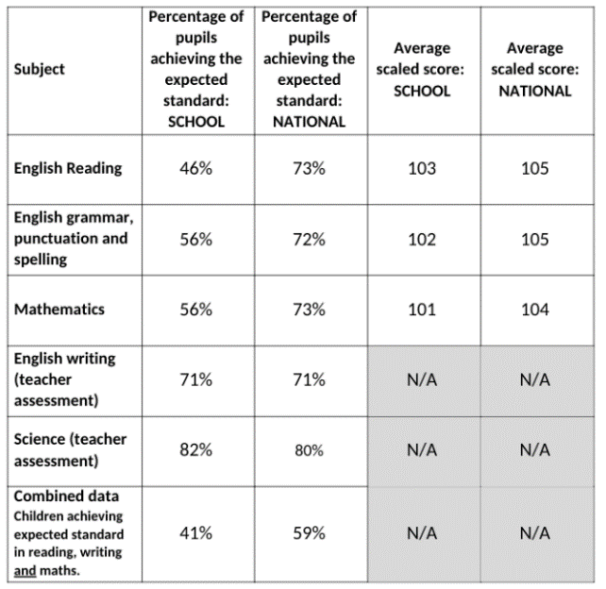
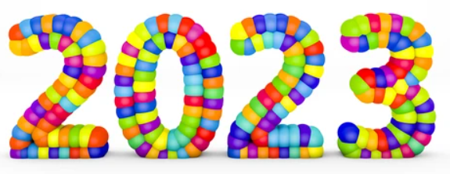
KS1 Teacher Assessments
Expected standard
68% reading
60% writing
73% maths
54% combined
KS2 SATS

EYFS
69% of our EYFS pupils
achieved a good level of development.
Year 1 Phonics Screening
71% of our Year One pupils passed the screening check.

